

F&Y Furniture Manufacturers CC – Reg No: 2003 / 029145 / 23

**Furniture Manufacturers & Importers of Quality Furniture**

H/O 40 Berg Road, P O Box 10083, Marburg, 4252

Tel: +27 (0)39 685 5747

Fax: +27 (0)39 685 5757

Email: [Veerad@multiwood.co.za](mailto:Veerad@multiwood.co.za;)

**PayFlex SOP**

**Introduction:**

The following process provides guidance and instructions to store managers, sales representatives and cashiers in respect of how to process an in-store sale for the By Now Pay Later application.

**Scope:**

This process applies to all store managers, sales representatives and cashiers who play a role in processing sales.

**Standard Operating Procedure:**

1. **In Store Process:** 
   1. Customer to download the Payflex App (Available on the App Store or Google Play Store) and has registered with their details. (200MB complimentary data supplied to customer as Guest Wifi, to action out download and registration).
   2. Once registration is done the customer will be able to check their spend limit. This will confirm the maximum they can afford.
   3. Once the customer has chosen their respective items, ask your customer to open the Payflex App and tap scan button, this will trigger the QR reader to scan your stores Payflex QR Code.
   4. Once the customer has scanned the QR code the App will present a payment plan for your customer to approve.
   5. Once customer approves, the Store Manager will receive an SMS confirmation and an email notification confirming if the payment was approved and successful.
   6. Order number from the Pay Just Now is added to the invoice memo column.
   7. Sale is tendered and then rung up on IQ, cashier to select the tender type “PayFlex”
   8. Goods dispatched by store as per standard dispatch process.
2. **Store Cash Up:**

2.1. Store Manager to contact Head Office for cash up amount via email.

2.2. Head Office will issue your daily cash up amount.

2.3. Store Manager/Cashier to subtract value for from Debit Note.

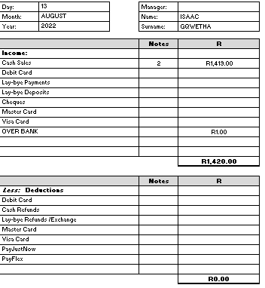



1. **Head Office Consolidation:**

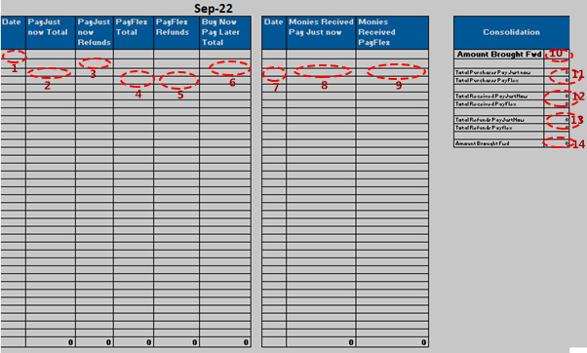

1. Trading date of store
2. Amount Banked Pay Just now
3. Amount Refunded Pay Just Now
4. Amount Banked PayFlex
5. Amount Refunded Payflex
6. Total Net BuyNow Pay Later For the Day
7. Date money received from buy now pay later
8. Amount received payjust now
9. Amount received from payflex
10. Amount brought forward from previous month
11. Total income for the month from payjustnow and payflex
12. Total recieved both the payment gateways
13. Total refunds through both payment gateways

Total to carry forward to the next month

**APPROVED BY:**

|  |  |  |  |
| --- | --- | --- | --- |
| **Name** | **Designation** | **Signature** | **Date** |
| Harry Ramsuruth Mothilal | IT Manager |  | 16 August 2022 |
| Veerad Ramsarup | HR Manager |  | 16 August 2022 |
| Abdullah Dindar | Managing Director |  | 16 August 2022 |