

F&Y Furniture Manufacturers CC – Reg No: 2003 / 029145 / 23

**Furniture Manufacturers & Importers of Quality Furniture**

H/O 40 Berg Road, P O Box 10083, Marburg, 4252

Tel: +27 (0)39 685 5747

Fax: +27 (0)39 685 5757

Email: [Veerad@multiwood.co.za](mailto:Veerad@multiwood.co.za;)

**Floor Check Summary**

**Introduction:**

The following process provides guidance and instructions to MFA Employees on how to perform a daily Floor Check at their respective store.

**Scope:**

This process applies to all MFA Employees who play a role in monitoring the daily and weekly Floor Checks.

**The below process must be followed when performing store floor checks:**

1. Product listing printed for a specific department and issued to the individual responsible for that department.
2. How to perform a floor check from Product listing:

* All items listed on the product listing must correspond with items displayed on the floor.
* Prices on displayed items must be correct and match the product listing.
* Displayed items that are damaged must be identified, must either be repaired or replaced.
* A floor check summary report must be completed as per below in order for management to plan accordingly. This spreadsheet must only be completed for items that are not displayed on the floor and the reasons as to why it is not displayed.

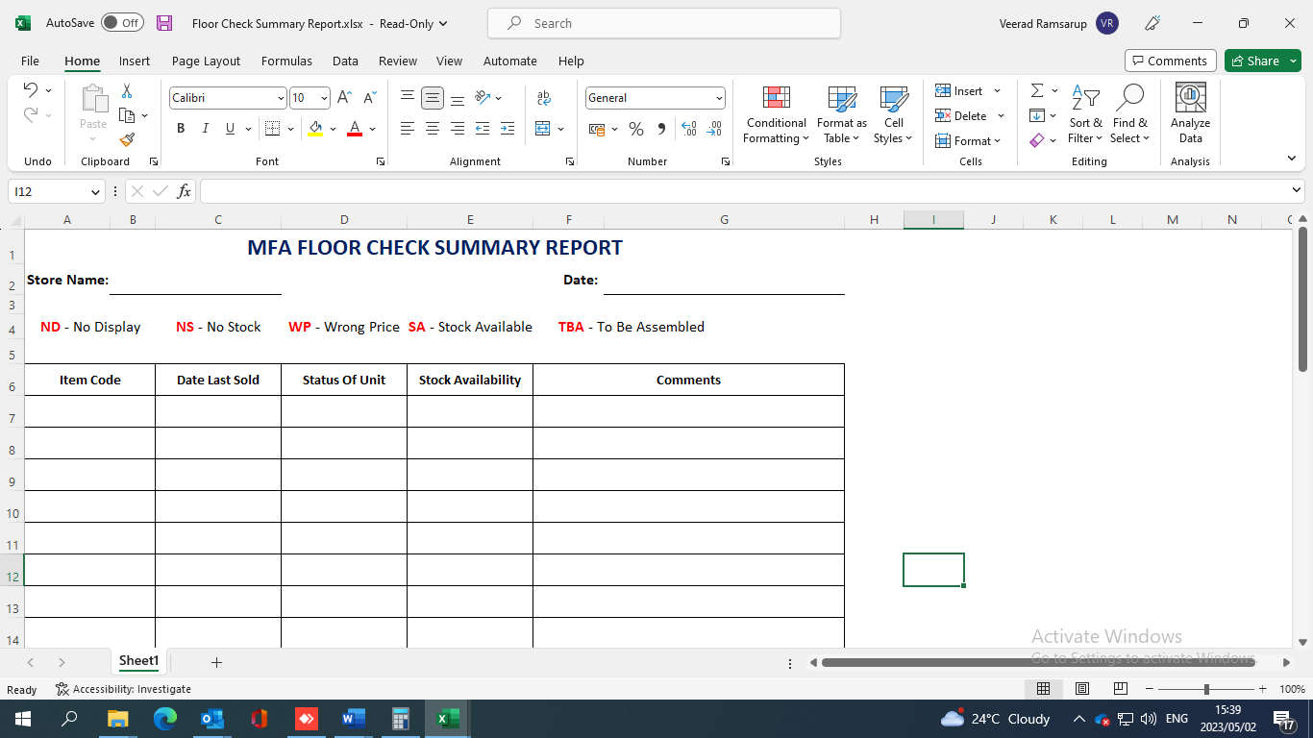

1. An assembly plan must be drawn up based on items that are not present on the sales floor and needs to be displayed and which items were received (example items received in different colours alternatively new items received) must be assembled and displayed onto the sales floor.

______________________ ____________________

Manager Signature Date

______________________ ____________________

Area Manager Signature Date